WASHINGTON COUNTY HOSPITAL AND CLINICS
Meeting of the Board of Trustees
July 27, 2023 – 4:00 p.m.

The Washington County Hospital and Clinics Board of Trustees met in the Robert Nicola Conference room to conduct the monthly Board meeting on Thursday, July 27, 2023 at 4:00 p.m. Board Members present were David Bruns, Ann Williams, Sue Basten, Ed Weeks, and Mike Van Osdol. Also present were Todd Patterson, Andrea Leyden, Stephan Schomer, MD, Lisa Zavala, and Shelli Cleverley.
Recorder: Vina Seeley
Press: None
Medical Staff: None
Public: None
WCHC Staff: Jessica Reed, Rachelle Sobaski, Lucas Kroll, Amanda Van Weelden, Bob Emry, Craig Pettit, John Woodward, Greta Clemons, Sarah J. Greiner, Amanda Kemp, Angie Atkins-Adams, Annie Dechant, Paige Chalupa, and Jenny Allen.
Basten called the meeting to order at 4:05 p.m.
REVIEW AGENDA
- No Changes
MINUTES (Basten)
The June 29, 2023 Board meeting minutes were presented. Minutes were reviewed and approved with a motion made by Weeks, seconded by Van Osdol. Motion approved 5-0.
BOARD EDUCATION
- Patient Satisfaction Update – FY23 Report
Leyden presented the Patient Satisfaction overall scores for FY23:
- Clinics – Overall provider rating of 90.60% and met goal of 90.55%
- Inpatient – Overall hospital rating of 82.05% and met goal of 75.50%
- Surgery – Overall facility rating of 86.73%% and did not meet goal of 87.90%
- Emergency – Overall mean score of 86.83 and met goal of 86.35
- Outpatient – Overall mean score of 92.66 and met goal of 92.01
- Provider Discussion (Williams & Van Osdol)
Van Osdol shared that he and Williams met with Ayoub Mogassbi, MD and James Schlichtmann, MD. He reported that Mogassbi shared that patient wait times (3-4 months) are a concern for him and that he is sad that Amy Martin left, but excited about Jasmine beginning and confident she will do well. There was discussion regarding QuickCare impact and concerns that there may be profit lost for lower-acuity care. Both providers are excited about the Epic conversion; however, there was concern regarding the option for patients to directly message the providers regarding care and hope that this will not be too taxing or time consuming.
Williams reported that it was great to get to know the providers a little better. Both providers see about 18 patients/day and Schlichtmann reported that he really enjoys working at Saturday Clinic as it gives him the opportunity to see younger patients. Both providers believe that Epic will provide greater consistency between appointments and charting. Schlichtmann reported that there have been issues regarding calling internally to the Main Line at the Hospital. Patterson and Zavala reported that they are currently working through this issue. Both providers mentioned that they enjoy charting at the end of the day. Schlichtmann reported that he plans to retire in a few years and hopes that he can participate in recruiting his replacement. He had some suggestions for having Residents come and do rotations in the clinic.
FINANCE
- Finance Committee Report
  - Key Indicators
    - Days Cash on Hand—Target: 195, Month: 162, FYTD: 170
    - Operating Margin—Target: 0%, Month: 34.7%, FYTD: 0.0%
    - Total Margin—Target: 4.0%, Month: 48.3%, FYTD: 5.5%
    - EBIDA Margin—Target: 10%, Month: 53.4%, FTYD: 9.9%
    - Gross AR Days—Target: 40, Month: 49, FTYD: 51
  - Operating Income Statement – FYE
    - Expenses: $2.8M — 31% under budget – IPERS performs an actuarial calculation at each FYE. These reports lag one year, so the measurement they used was from June 2022 data. This calculation is set up to amortize these amounts over 5 years, which is designed to limit large swings YOY, even though that is what occurred for FY23. Total adjustment created a $1.9M decrease in expenses.
- Overall Income Statement – FYE
  - Net Patient Service Revenue: $42M – 2% better than budget, 2% better YOY
    - Audit adjustments will increase revenue and expenses
  - Other Operating Revenue: $8.2M – meeting budget, 7% better YOY
  - Total Op Revenue: $50M – 2% better than budget, 2% better YOY
  - Operating expenses: $50M – 19% under budget
    - Higher expenses due to unbudgeted wage increases, EE benefits, Supplies, and Agency. Admin is working on expense mitigation strategies for FY24.
- YTD Income from Operations: $330.00
- Net Income $2.7M – FYTD unrealized gain on investment = $395k
- EBIDA: $5M – 4% better than budget
- Benefit Adjusted Income Statement – FYE – Less IPERS and OPEB adjustments
  - Operating expenses: $52M – 6% over budget and 13% higher YOY
  - YTD Loss from Operations: ($1.8M)
  - Net Income $951k
  - EBIDA: $3M
MEDICAL STAFF REPORT (Schomer)
- The MEC met on 07/25/23 and Schomer shared that the presented policies and credentialing were recommended for approval. Quality & Safety Committee incident reporting trends included one medication error and one needlestick. Gipple is working on the CRM build which will be used for incident reporting after Epic Go-live. Quality workgroups are working on dashboards, streamlining the Ortho Pre-op process and improving the Accidental Needlestick protocols. There was discussion on a provider who would like to train a therapy dog for primary care visits and the MEC had many concerns regarding this service being provided in an acute health care setting. MEC also approved two new Delineation of Privileging forms for Family Medicine and Emergency Medicine.
PERSONNEL
- Personnel/Credentials Request (Basten)
- The Personnel Committee met on July 27, 2023 to review and approve the following credentialing/privileging files:
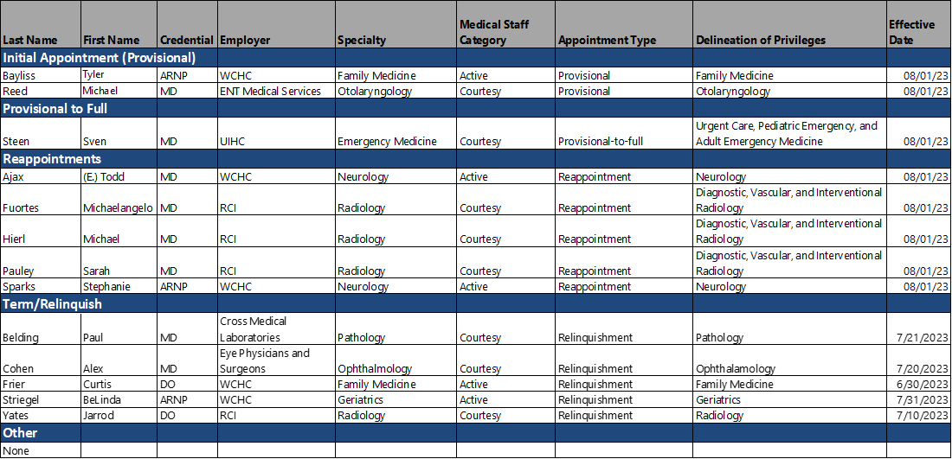
- Basten reported that the Personnel Committee unanimously approved all credentialing/privileging files.
- Basten reported that there were five Compliance policies and one Clinic Ops policy that were reviewed and approved by the Personnel Committee.
CEO REPORT (Patterson)
- CEO Update
  - Michael Reed, MD will begin on 08/04 with rotations in the Outreach Clinic. He will replace Dr. Capper.
  - Verbal agreement with a podiatrist for employment. Patterson has requested this provider to develop an approach for nail and diabetes care and support for wound care.
  - Tyler Bayliss, ARNP will begin on 7/31/23 and will provide long-term regulatory care in the interim until Vantiger begins in October.
  - Target for staff survey was met. The results will be available this Fall and will be brought to the Board for review.
  - Economic Impact Report FY23
    - WCHC is responsible for 570 total jobs in Washington County
    - WCHC provides nearly 12% of wages in Washington County and 7.5% GEP
- Plant Operations (Pettit)
  - Pettit shared current work in progress including punchwork and injection testing. Gear has passed by the State Fire Marshall. Power-up will begin on 7/28. On 8/18 there will be a power-changeover to transition over to complete plant power. Pettit also shared a virtual tour of the Plant Ops tunnel and main facility.
  - Specialty Clinic is nearing completion. Ajax’s office will be the only portion left to be completed after the power changeover.
PLAN NEXT MEETING AGENDA
The next regular Board of Trustees meeting will be held on September 28, 2023 at 4:00 p.m.

Closed Session
At 5:15 Weeks moved to go into go into closed session according to:
State of Iowa Code Chapter 21.5(1)(l) for Strategic Planning/Community Based Care
“To discuss patient care quality and process improvement initiatives in a meeting of a public hospital or to discuss marketing and pricing strategies or similar proprietary information in a meeting of a public hospital, where public disclosure of such information would harm such a hospital’s competitive position when no public purpose would be served by public disclosure.”
Present for the closed session were David Bruns, Ann Williams, Sue Basten, Ed Weeks and Mike Van Osdol. Also present were Dr. Stephan Schomer, Todd Patterson, Andrea Leyden, Shelli Cleverley, Lisa Zavala, and Vina Seeley. All were present at the time of voting to go into the Closed Session. Motion to move into closed session by Weeks, seconded by Williams. The motion carried 5-0 with the vote as follows: Bruns-yes, Basten-yes, Williams-yes, Van Osdol-yes, and Weeks-yes.
At 5:55 p.m. the Board moved to go into open session. Weeks made a motion to return to open session, seconded by Van Osdol. The motion carried 5-0 with the vote as follows: Bruns-yes, Basten-yes, Williams-yes, Van Osdol-yes, and Weeks-yes.

No action taken in open session.
With there being no other business, the meeting adjourned at 5:55 p.m.

_____________________________________ ____________________________________
David Bruns, Chair Ann C. Williams, Secretary

